Lab Tasks

- Design and configure the network given in figure given below and check the connectivity by PING command. Also describe the functionality of devices in given scenario. Show the packet header format of ARP in Cisco Packet Tracer.
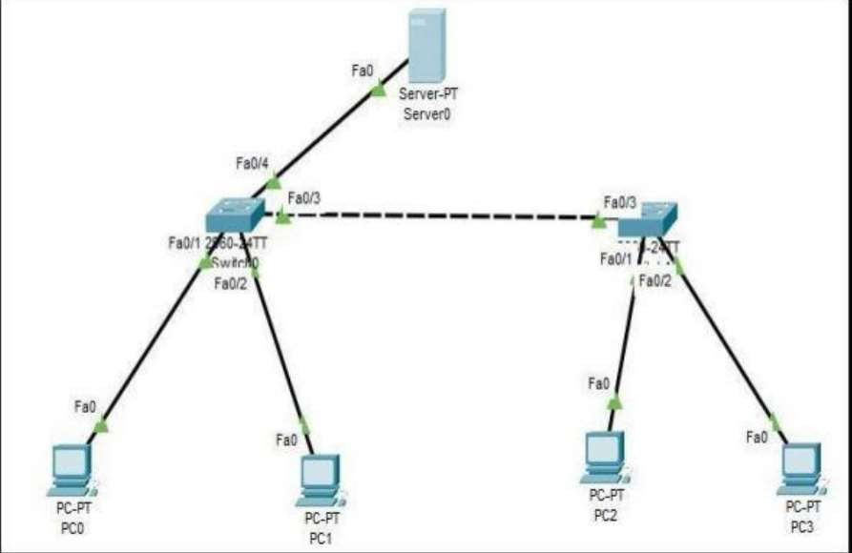

Checking Connectivity between PC2 and PC1:
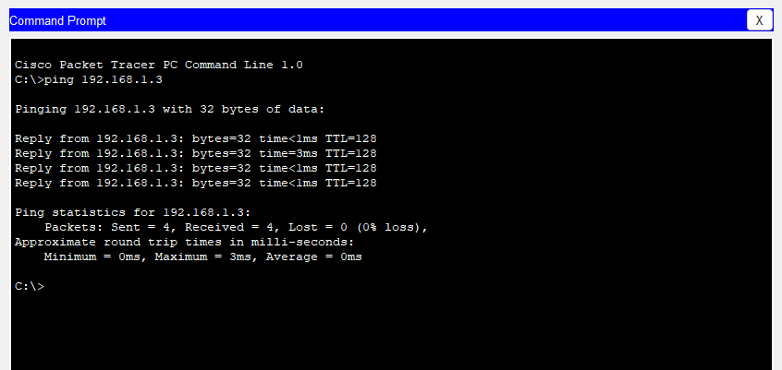

There are 4 Personal Computers that communicates to devices on the network, connected via switches. The two switches (Switch0 and Switch1) are connected to each other, facilitating communication between devices connected to each switch. This creates an extended network where all PCs and the server can interact. The Central Server (Server0) offer services like File Storage.

Packet Header Format of ARP:

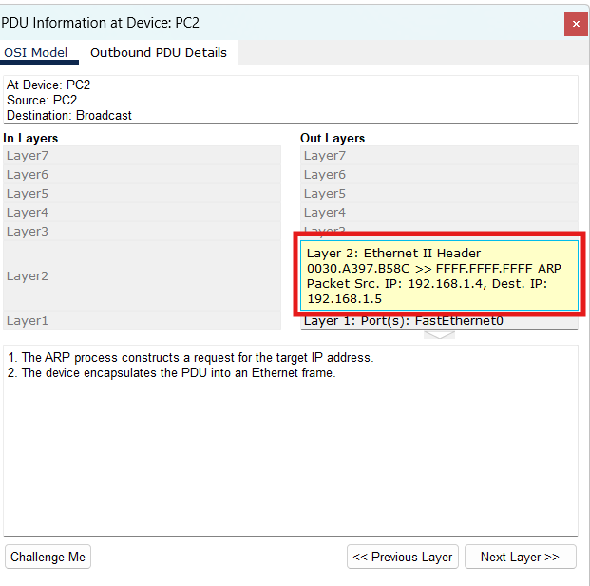

- Identify the difference between Switch and Hub?

Hub is a networking device that connects multiple end devices in a local network. It broadcasts data packets to all devices connected to it. (AKA ‘Muhallay ki phuppo’)

While Switch is a more intelligent networking device that connects multiple computers and directs data packets only to the specific device.

- Differentiate between physical and logical mode?

The Physical mode shows the actual physical layout of the network. It displays devices such as routers, switches, and computers as they would be physically connected in a real-world.

The Logical mode focuses on the conceptual representation of the network. It shows how devices are logically connected and how data flows between them.
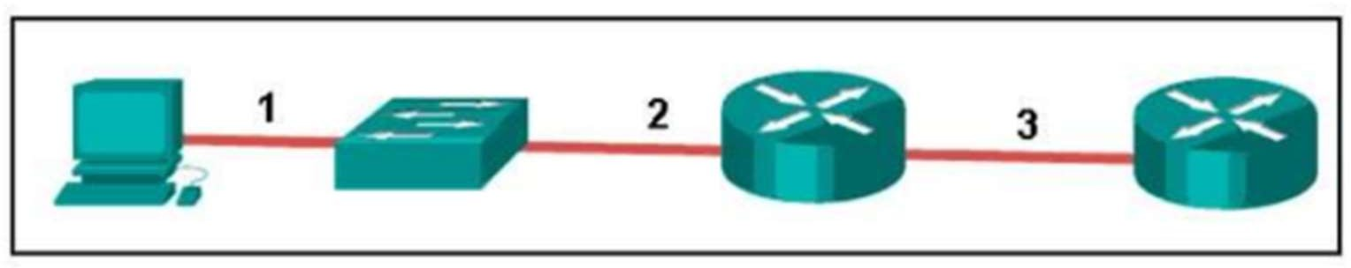
- Consider the following figure. The PC is connected to the console port of the switch. All the other connections are made through Fast Ethernet links. Which types of UTP cables can be used with segment 1, 2 and 3?
ANS:
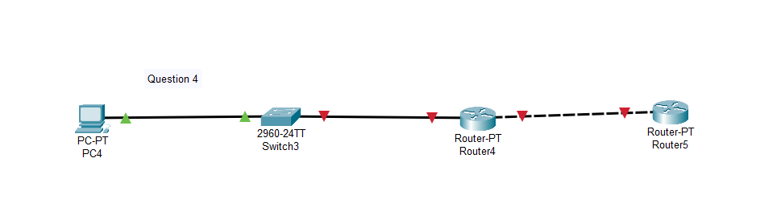

- Create a network using Packet Tracer having eight PC with 4 of them in one broadcast domain and remaining 4 in other broadcast domain achieve this by using HUB and Bridge. Show steps in form of screen shots also explain the working of bridge.
[HINT: HUB has single Broadcast and collision domain; broadcast domain mean all devices connected will receive data of every transaction, USE 2 HUB and 1 Bridge having 8 PCs in Network].
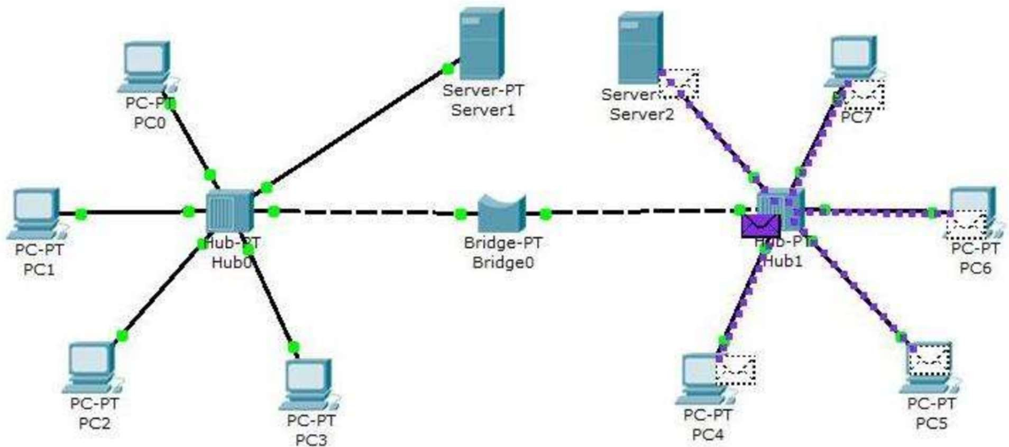
Ans:

Server is connected to Hub using Straight through wire, allowing multiple devices to connect to the server:

